EDA USING POWER BI REPORT
WEEK – 2

DATA MODELING & DASHBOARD CREATION - SUPERSTORE DATASET

SUBMITTED BY
Divya Dharshni P
E25DA014
- Dataset:
Superstore Sales Dataset (Preprocessed from Week 1)
- Problem Statement:
Management wants an interactive dashboard to monitor sales, profit, orders, customers, and regional performance.
- Objective:
To create a Star Schema data model and an interactive dashboard for Superstore sales analysis using Power BI.
- Tools Used:
Power BI Desktop, Sample Superstore Dataset
- Steps Performed:
Step 1: Data Cleaning & Dimensional Modeling
Created 4 Dimension Tables from the main table:
- Dim_Product (Product ID, Category, Sub-Category, Product Name)
- Dim_Customer (Customer ID, Customer Name, Segment)
- Dim_Region (Region, State, City) - Removed duplicates, kept only Region column for relationship
- Dim_Date (Order Date, Year, Month, Month Name)
Main Fact Table: samplesuperstore.
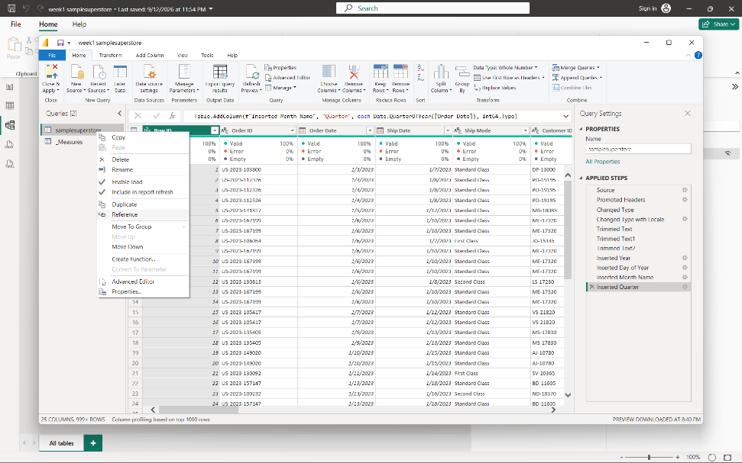
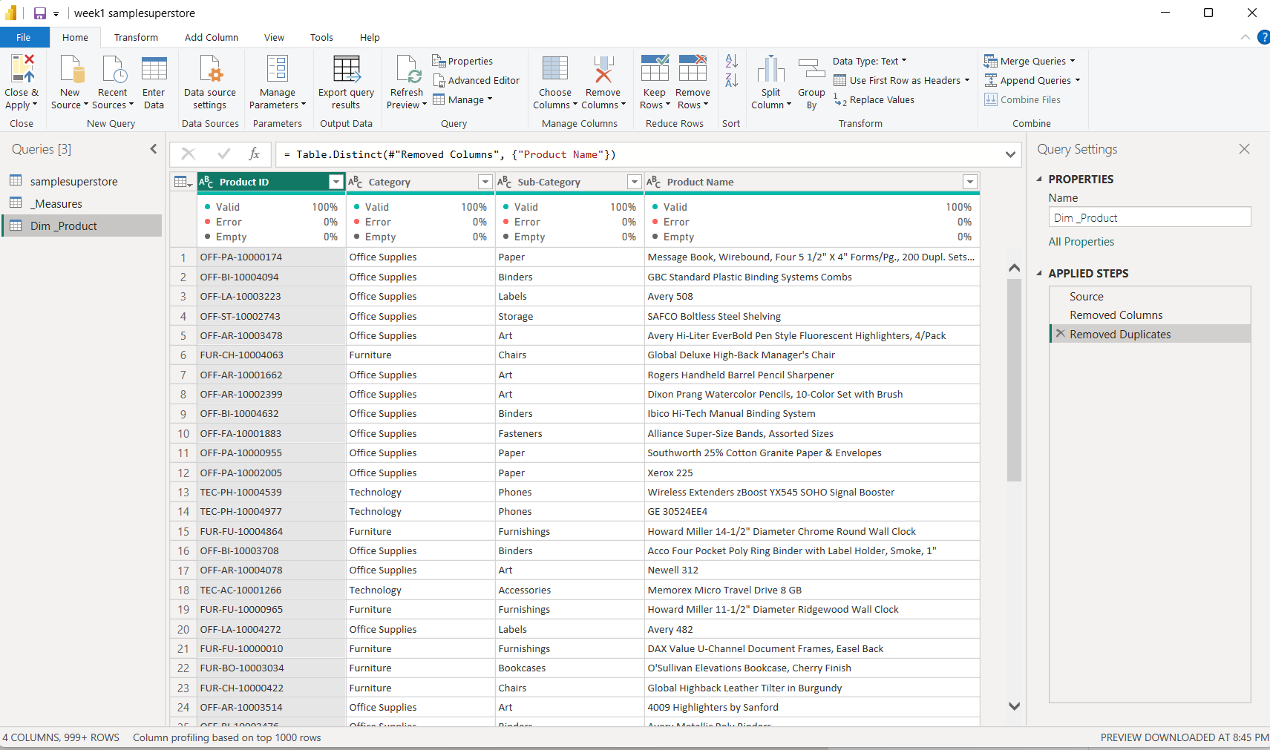
In this above screenshots, Dim_Product table has been created .
Same as Dim_Product, other Dimension tables have also been created.
Here, we can see that in the below screenshot.
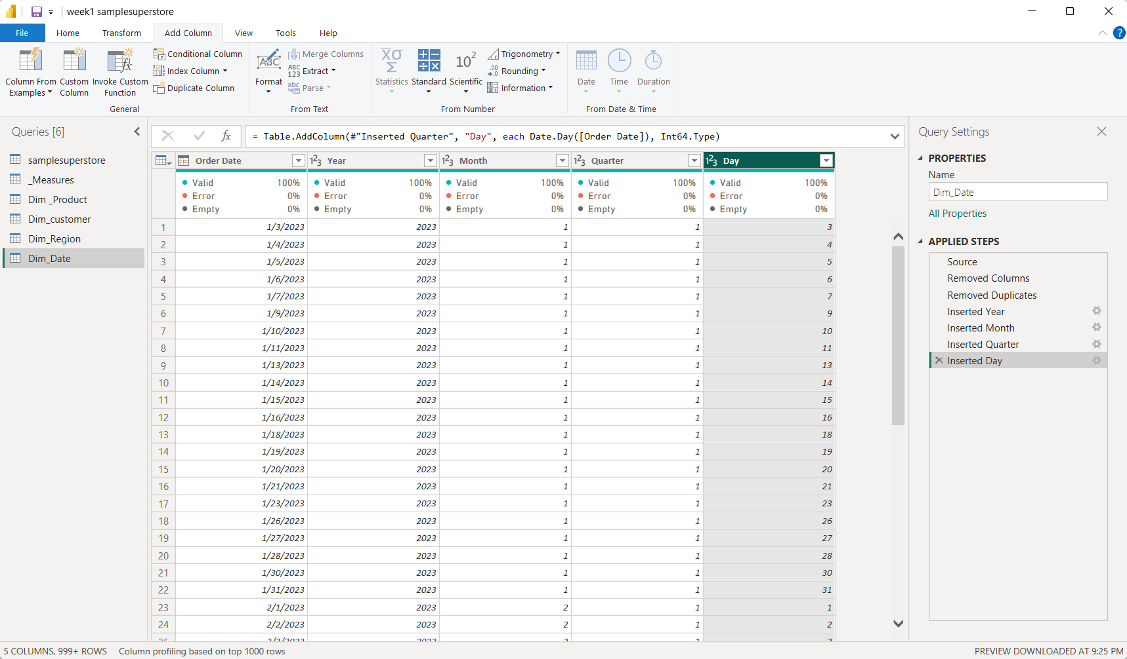
Step 2: Created Measures Table (_Measures)

Created a separate measure table with 4 DAX measures:
- Total Sales = SUM(samplesuperstore[Sales])
- Total Profit = SUM(samplesuperstore[Profit])
- Total Orders = COUNTROWS(samplesuperstore)
- Profit Margin % = DIVIDE([Total Profit], [Total Sales])
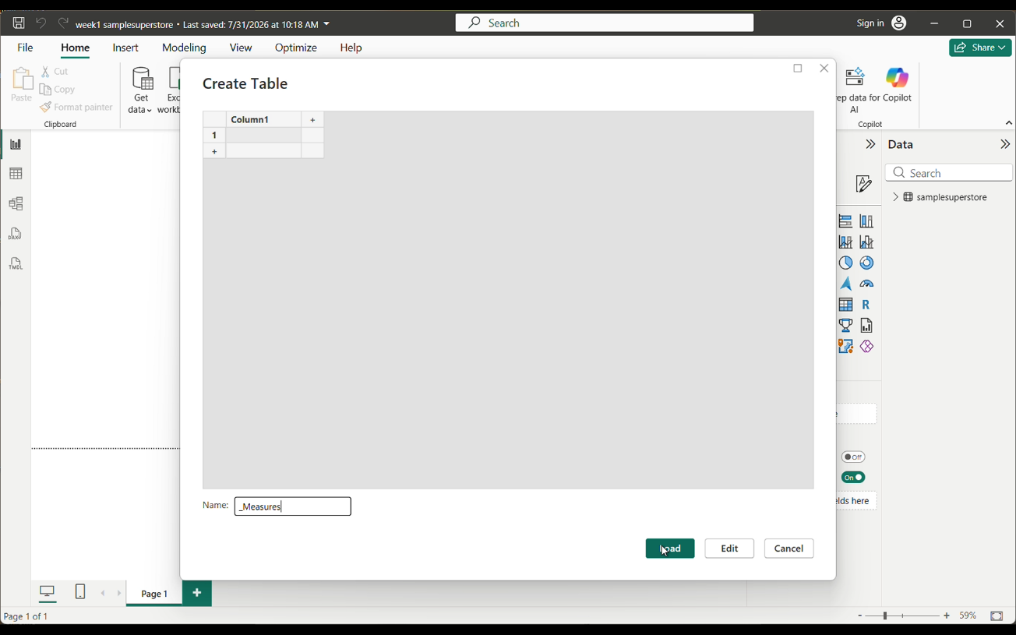
_Measures table has been created in the above screenshot.
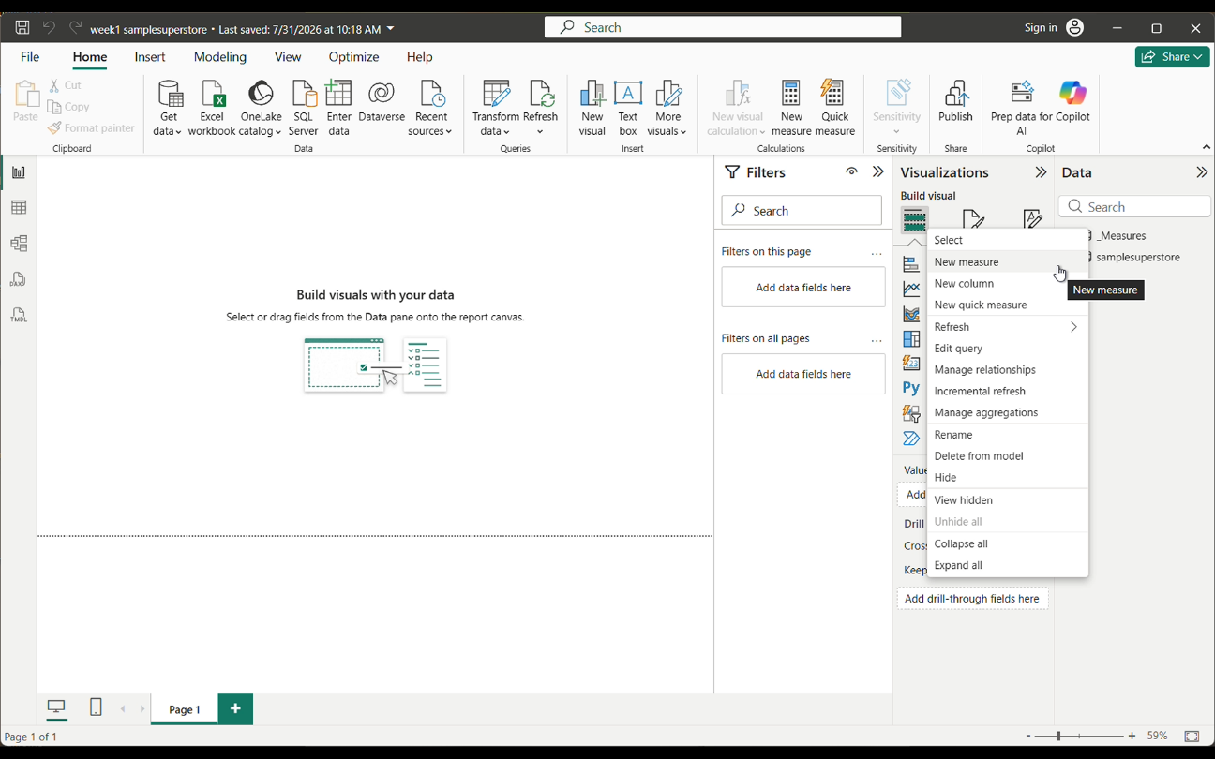
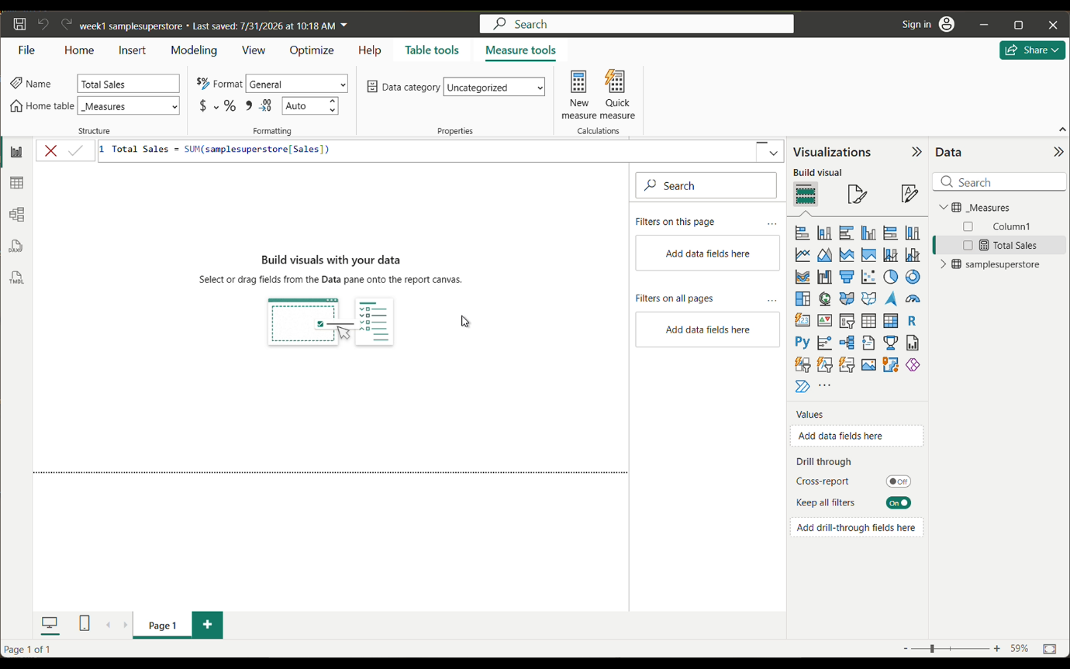
By clicking New Measure,Total Sales has been created by using DAX measure.
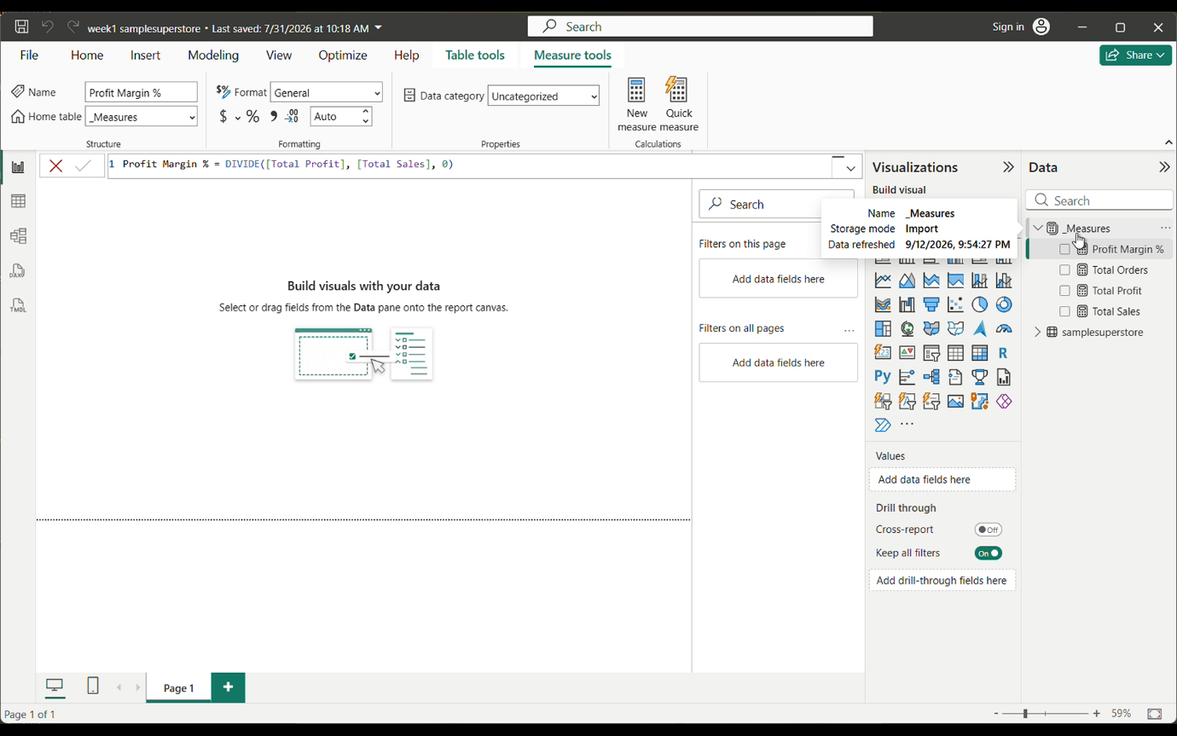
In this above screenshot we can able to see other 3 DAX Measures have also been created.
Step 3: Star Schema Modeling (Model View)
Established relationships (1 to Many, Single Direction):
- Dim_Product[Product ID] (1) -> samplesuperstore[Product ID] (_)
- Dim_Customer[Customer ID] (1) -> samplesuperstore[Customer ID] (_)
- Dim_Date[Order Date] (1) -> samplesuperstore[Order Date] (_)
- Dim_Region (1) -> samplesuperstore (_)[Region]
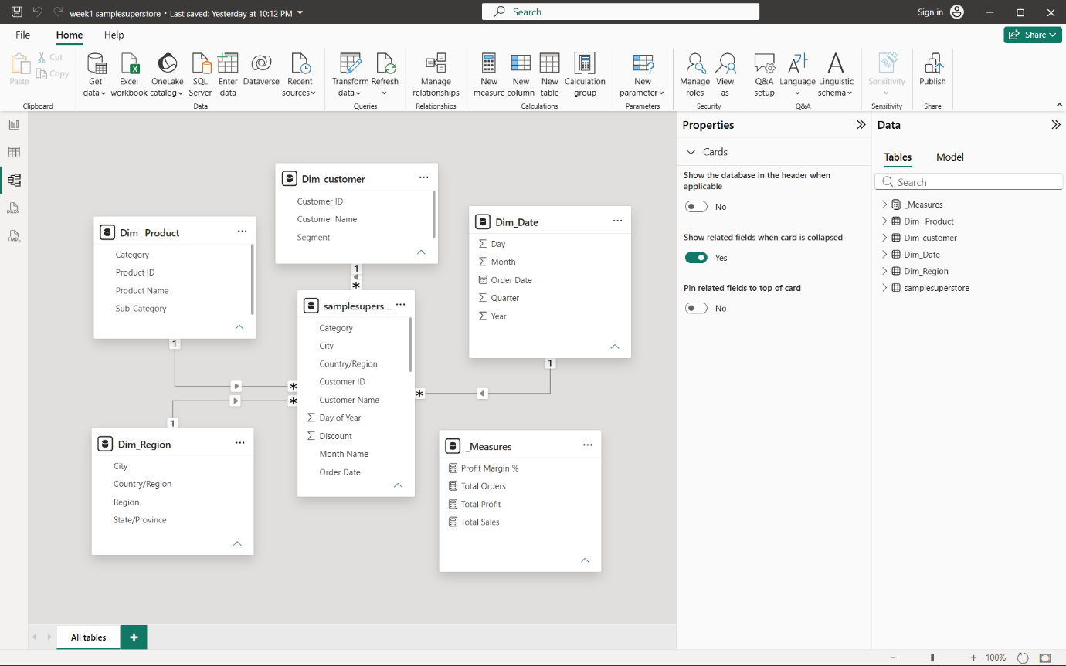
Step 4: Dashboard Creation (Report View)*
KPI Cards:
Total Sales (2.33M), Total Profit (292.30K), Total Orders (10K), Profit Margin % (12.56%) using _Measures.
Visuals:
- Bar Chart: Total Profit by Region (X-axis: Dim_Region, Y-axis: _Measures[Total Profit])
- Bar Chart: Total Sales by Sub-Category (X-axis: Dim_Product[Sub-Category],
- Y-axis: _Measures[Total Sales])
- Slicers: Region (Dim_Region), Category (Dim_Product), Year (Dim_Date), Segment (Dim_Customer)[Region]
- Line Chart: Total Sales by year(X-axis: Order date -year (Dim_Date),Y-axis: Measures[Total Sales])
- Decomposition Tree: Analyse(_Measures[Total Sales]),Explain by(Dim_Product [Sub-Category,Category],(Dim_Region[Region]).
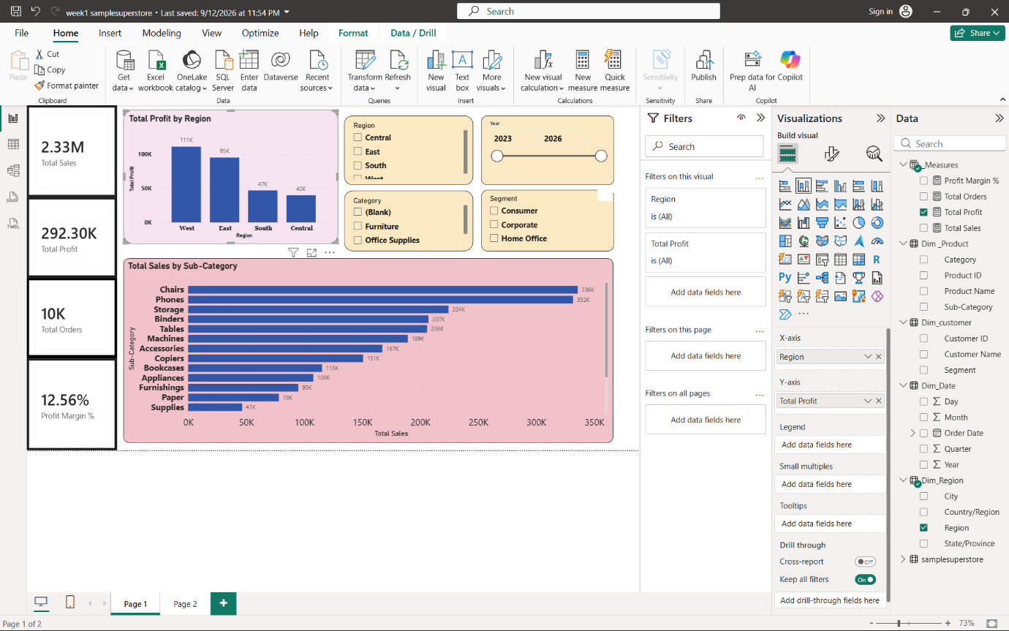
KPI cards , slicers and Stacked Column chart are shown in the above screenshot.
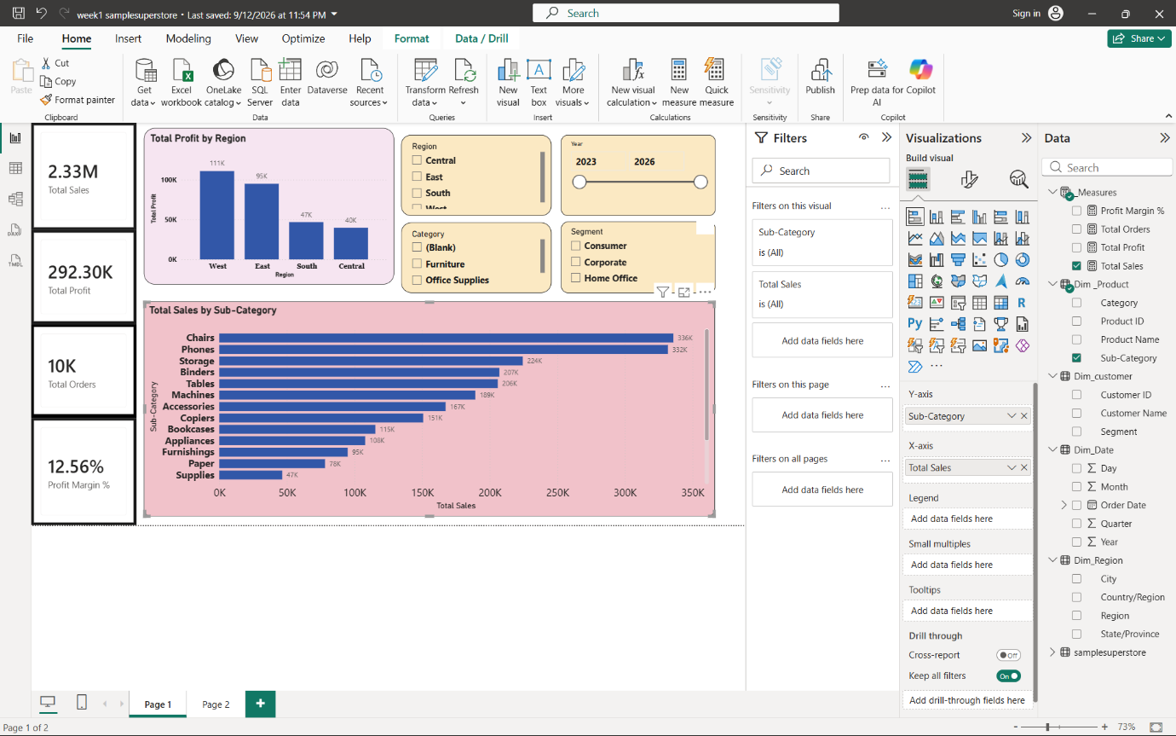
A Stacked Bar chart is shown in the above screenshot.
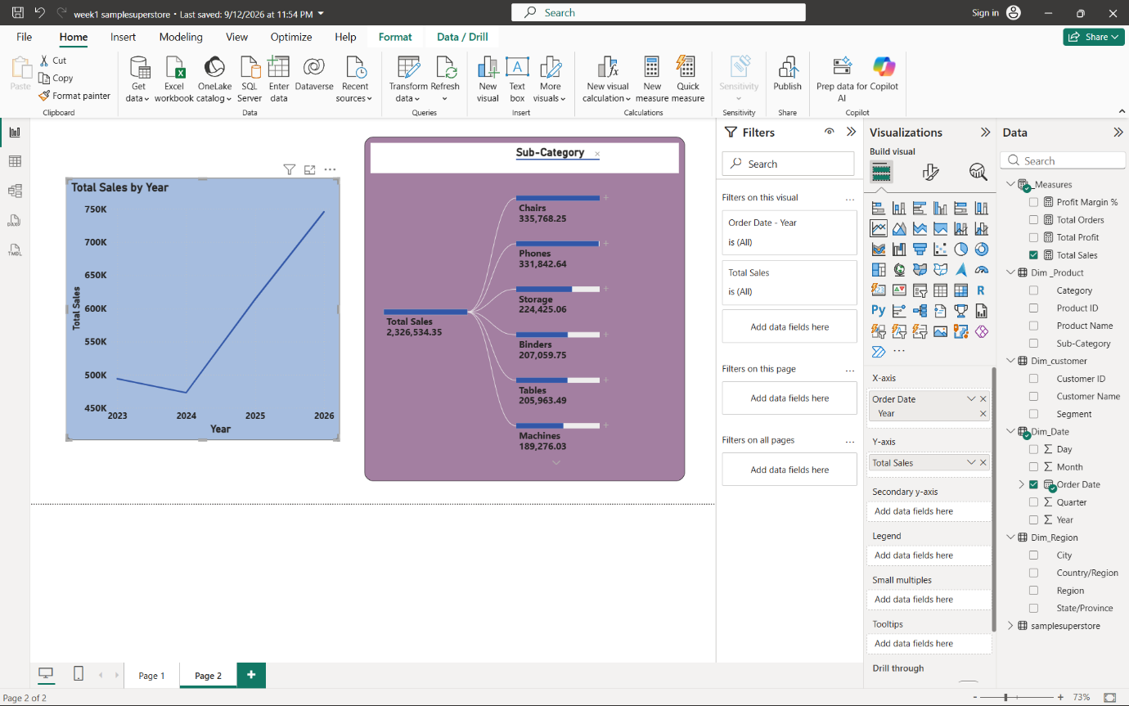
A Line chart is shown in the above screenshot.
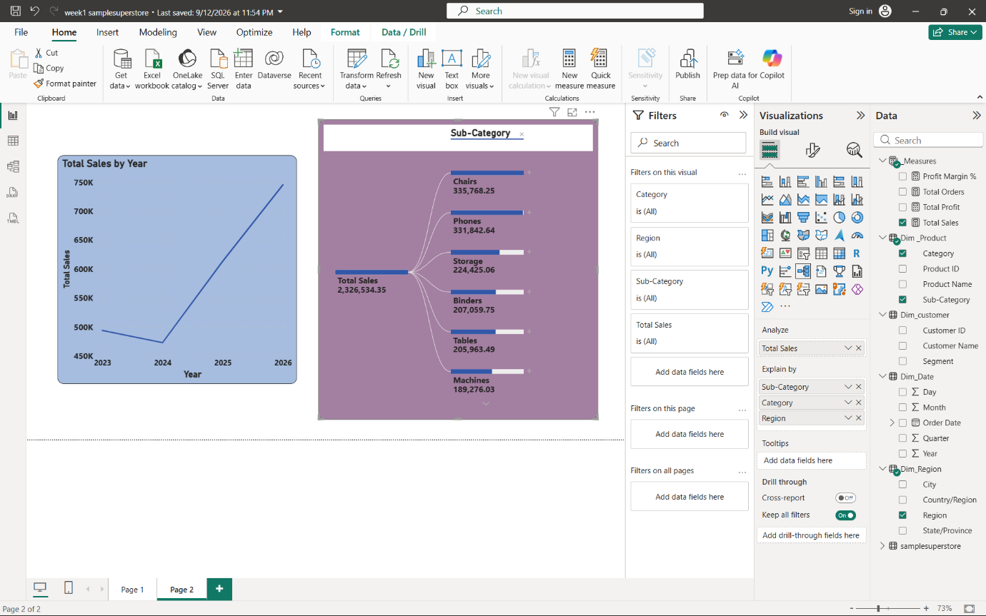
A Decomposition Tree is shown in the above screenshot.

- Conclusion :
Learned the importance of Star Schema for performance and accurate filtering. Understood that Measures provide the calculations (What to show) and Dimension tables provide the context (By What to filter). The dashboard now filters correctly without duplicate issues.

